Lecture #1

Synopsis

Interfacing – Definition

Transmission modes

Architecture of 8255
    - Target
By this lecture you should be able to answer the following questions
  - How many ports are on 8255?
  - Explain the control word format of 8255 in BSR mode.
  - Describe different modes of 8255.

3. Introduction
The primary function of microprocessor is to accept data from input such as keyboard & A/D converters, read instructions from memory, process data according to the instructions, and send the result to output devices such as LED’s, printers and video monitors.
4. Concepts
Definition
Designing logic circuits and writing instructions to enable the microprocessor to communicate with these peripherals is called interfacing.
Microprocessor communicates to peripherals in either of two formats: synchronous and asynchronous. Similarly, transfers data in either of two modes: memory mapped I/O or peripheral I/O, on the basis of interfacing logic circuits.
Transmission format:
- Synchronous
- Asynchronous
Modes of Data transfer
- Parallel: here, the entire word is transferred at one time. Keyboards, LED’s, data converters and memory are generally use the parallel data transfer mode.
- Serial: Data is transferred one bit at a time over a single line between microprocessor and peripheral. Printers, CRT terminals and modem for telephone line use parallel mode of data transfer.
Types of I/O
- Peripheral
- Memory mapped
Programmable peripheral Device
A Programmable device is designed to perform various input/output functions. The device can be set up to perform specific functions by writing an instruction to the control register. And the functions can be changed at any time during execution of the program by writing a new instruction into the control register.
Organization and architecture of 8255
8255A is a general purpose, programmable, parallel I/O device. It has 24 I/O pins that can be grouped primarily in two 8-bit parallel ports: A and B, with the remaining eight bits as port C. The eight bits of port C can be used as individual bits or can be grouped in two 4-bit ports: C_{upper} & C_{lower}. The functions of these ports are defined by writing a control word in the control register.

8255A I/O ports

Port A

8255A

C_{u}
C_{l}

Port B

The functions of 8255A can be classified according to two modes: bit Set or Reset mode (BSR) and the I/O mode. The BSR mode is used to set or reset the bits in port C. The functions of each port are defined in I/O mode. The I/O mode can be further divided into three modes: Mode0, Mode 1 & Mode 2.
Operational Modes
MODE 0
When a port is used for simple input or output operation without handshaking, then it is initialized in Mode 0.If both the ports A and B are used in Mode 0, the port C can be used as an additional port or as an individual 4-bit port.
MODE 1
When a the port A or Port B are used for handshake input or output operation, then the port is initialized in Mode 1. In this mode, some of the pins of port C are used as handshaking lines.
Port Mode Handshake lines
A Input PC0, PC1, PC2
A Output PC0, PC1, PC2
B Input PC3, PC4, PC5
B Output PC3, PC6, PC7

MODE 2
Only port A can be initialized in Mode 2. In mode 2, the port A is used for bidirectional data transfer. The data can output or input on the same eight lines. Then, PC3-PC7 are as handshake lines for Port A. The other Port c lines are used for I/O if port B is initialized in Mode 0 or as handshaking signals if Port B is in Mode 1.

Port address is determined by CS, A1 and A0 lines. CS goes low when A7=1 & A2- A6 are zero.

CS  A7 A6 A5 A4 A3 A2 | A1 A0 | Hex Address | Port
1 0 0 0 0 0 0 0  1 0 0 0 0 0 0 0  1 0 0 0 0 0 0 0  1 0 0 0 0 0 0 0 | 0 0  0 1  1 0  1 1 | 80 H  81 H  82 H  83 H | A  B  C  Control register

A1 | A0 | SELECTION
0 | 0 | PORT A
0 | 1 | PORT B
1 | 0 | PORT C
1 | 1 | CONTROL

Control Word
The content of control register is control word, which specifies I/O function for each port. The register can be accessed to write a control word when A0 and A1 are at logic 1. The register is not accessible for read operation.
Control Word format of 8255
8255 can operate in two modes Input/Output mode and Bit set/Reset Mode. To make the operation possible in either of these modes, we write control words to control register. If bit 7 of the control word is a logical 1 then the 8255 will be configured in I/O mode
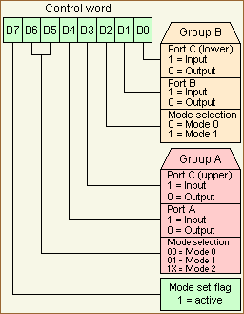
If bit 7 of the control word is a logical 0 then each bit of the port C can be set or reset.
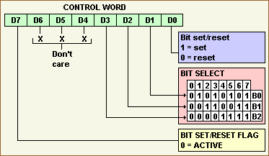

Architecture

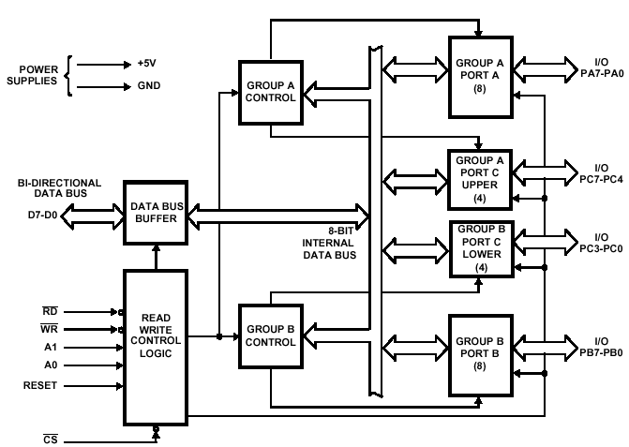

Data Bus Buffer
This three-state bi-directional 8-bit buffer is used to interface the 8255 to the system data bus. Data is transmitted or received by the buffer upon execution of input or output instructions by the CPU. Control words and status information are also transferred through the data bus buffer.
Read/Write and Control Logic
The function of this block is to manage all of the internal and external transfers of both Data and Control or Status words. It accepts inputs from the CPU Address and Control busses and in turn, issues commands to both of the Control Groups.
(CS) Chip Select: A "low" on this input pin enables the communication between the 8255 and the CPU.
(RD) Read: A "low" on this input pin enables 8255 to send the data or status information to the CPU on the data bus. In essence, it allows the CPU to "read from" the 8255.
(WR) Write: A "low" on this input pin enables the CPU to write data or control words into the 8255.
(A0 and A1) Port Select 0 and Port Select 1. These input signals, in conjunction with the RD and WR inputs, control the selection of one of the three ports or the control word register. They are normally connected to the least significant bits of the address bus (A0 and A1).
(RESET) Reset. A "high" on this input initializes the control register to 9Bh and all ports (A, B, C) are set to the input mode.

Group A and Group B Controls
The functional configuration of each port is programmed by the systems software. In essence, the CPU "outputs" a control word to the 8255. The control word contains information such as "mode", "bit set", "bit reset", etc., that initializes the functional configuration of the 8255. Each of the Control blocks (Group A and Group B) accepts "commands" from the Read/Write Control logic, receives "control words" from the internal data bus and issues the proper commands to its associated ports.
Ports A, B, and C
The 8255 contains three 8-bit ports (A, B, and C). All can be configured to a wide variety of functional characteristics by the system software but each has its own special features or "personality" to further enhances the power and flexibility of the 8255.
Port A One 8-bit data output latch/buffer and one 8-bit data input latch. Both "pull-up" and "pull-down" bus-hold devices are present on Port A.
Port B One 8-bit data input/output latch/buffer and one 8-bit data input buffer.
Port C One 8-bit data output latch/buffer and one 8-bit data input buffer (no latch for input). This port can be divided into two 4-bit ports under the mode control. Each 4-bit port contains a 4-bit latch and it can be used for the control signal output and status signal inputs in conjunction with ports A and B.

………………………………………………………………………………

Lecture #2

Synopsis

Programmable Keyboard/Display Interface – 8279

Pinout of 8279

Block diagram & function

Matrix keyboard interfacing
- Target
By this lecture you should be able to answer the following questions
- Explain the necessity of display RAM in 8279
- How a key debounce can be checked? Explain

3. Introduction
8279 is a hardware approach to interfacing a matrix keyboard and a multiplexed display that scans and encodes upto a 64-key keyboard and controls upto a 16-digit numerical display.. It is a 40-pin device with two major segments keyboard and display. The keyboard segment can be connected to a 64 contact key matrix. The keyboard entries are debounced and stored in the internal FIFO memory; and an interrupt signal is generated with each entry. The display segment can provide a 16-character scanned display interfaces with devices like LED’s. This segment has 16*8 R/W memory, which can be used to read or write information for display purposes.

4. Concepts

Pinout Definition of 8279
- A0: Selects data (0) or control/status (1) for reads and writes between micro and 8279.
- BD: Output that blanks the displays.
- CLK: Used internally for timing. Max is 3 MHz.
- CN/ST: Control/strobe, connected to the control key on the keyboard.
- CS: Chip select that enables programming, reading the keyboard, etc.
- DB7-DB0: Consists of bidirectional pins that connect to data bus on micro.
- IRQ: Interrupt request, becomes 1 when a key is pressed, data is available.
- OUT A3-A0/B3-B0: Outputs that sends data to the most significant/least significant nibble of display.
- RD(WR): Connects to micro's IORC or RD signal, reads data/status registers.
- RESET: Connects to system RESET.
- RL7-RL0: Return lines are inputs used to sense key depression in the keyboard matrix.
- Shift: Shift connects to Shift key on keyboard.
- SL3-SL0: Scan line outputs scan both the keyboard and displays

Programmable Keyboard/Display Interface - 8279
- A programmable keyboard and display interfacing chip.
  - Scans and encodes up to a 64-key keyboard.
  - Controls up to a 16-digit numerical display.
- Keyboard has a built-in FIFO 8 character buffer.
- The display is controlled from an internal 16x8 RAM that stores the coded display information.
Keyboards consist of a large matrix of keys, all of which are monitored by an on-board processor called the "keyboard encoder". The specific processor varies from keyboard-to-keyboard but they all basically do the same thing: Monitor which key(s) are being pressed/released and send the appropriate data to the host. This processor takes care of all the debouncing and buffers any data in its 16-byte buffer, if needed.
Motherboard contains a "keyboard controller" that is in charge of decoding all of the data received from the keyboard and informs software of what's going on.

Functional block diagram of 8279

DB₀-DB₇
Data Bus Buffer
FIFO/ Sensor RAM Status
Timing &
Control
Display
Register
Beyboard debounce
& Control
8 * 8 FIFO/ Sensor RAM
16 * 8 Display RAM
Display Addr Reg
Return
Scan Counter
I/O Control

8

CLK RESET IRQ

Control & Timing Reg

The functional block diagram of 8279 has four major sections
    - Keyboard
    - Scan
    - Display
    - CPU Interface
Keyboard section consists of eight return lines RL0-RL7, that can be used to form the columns of a keyboard matrix. It has two additional inputs shift and control/strobe. The keys are automatically debounce. It also has a 8X8 FIFO RAM. It can store 8 keycodes. The status of the shift and control key are also stored along with keycode. 8279 generates an interrupt signal when there is an entry on FIFO.
Display section has eight output lines divided into two groups A0-A3 and B0-B3. The output lines are connected to the anodes through driver transistor in case of common cathode 7 segment LED. The display can be blanked by BD line. The display section consists of 16X 8 display RAM which can also be organized into dual 16X4. The CPU load the display codes in this RAM.
Scan section has a scan counter and four scan lines, SL0-SL3. The scan lines are used to form the rows of a matrix keyboard and the digit drivers of a multiplexed display.
CPU interface takes care of data transfer between 8279 and the processor. This section has eight bi-directional data lines DB0-DB7 for data transfer.
When a key is pressed it bounces for a short time. If a key code is generated immediately after sensing a key actuation, then the processor will generate the same keycode a number of times. A key typically bounces for 10 to 20 ms. Hence the processor has to wait for the key bounces to settle before reading the keycode.

Interfacing a matrix keyboard with 8085

A matrix keyboard is where there are more than eight keys. A keyboard with 16 keys can be arranged in a 4 x 4 matrix. It requires eight lines from the microprocessor to make all the connections. When a key is pressed, it shorts one row and column. The interfacing of a matrix keyboard requires two ports: one output port and one input port. Rows are connected to the output port and the columns are connected to the input port.

- Ground all the rows by sending logic 0 through the output port
- Check the columns by reading the input port. If no key is pressed, all columns remain high. Continue the above two steps until the reading indicates a change
- When one of the keys is pressed, the corresponding column goes low; identify and encode the key

The columns and rows make contact only when a key is pressed. Otherwise it remains high. When the key is pressed, the intersection of row and column must change from high to low. The column lines of the keyboard are connected to the return lines, RL0-RL7 of 8279. As a low is put on each row, the 8279 checks these return lines one at a time to see any of them is low. If it finds any of return lines low, indicating a keypress, it waits a debounce time of about 10.3 ms and checks again. If keypress is still present, the 8279 produces an 8-bit code to represent the pressed key. After sending the packet information of pressed key, it stores the byte in an internal FIFO RAM. IT also asserts the IRQ pin high and increment the FIFO count in the internal status register.

Scan Codes
The keyboard's processor spends most of its time "scanning", or monitoring, the matrix of keys. If it finds that any key is being pressed, released, or held down, the keyboard will send a packet of information known as a "scan code" to the computer.
There are two different types of scan codes: "make codes" and "break codes". A make code is sent when a key is pressed or held down. A break code is sent when a key is released. Every key is assigned its own unique make code and break code so the host can determine exactly what happened to which key by looking at a single scan code. The make code only represents a key on a keyboard--it does not represent the character printed on that key. This means that there is no defined relationship between a make code and an ASCII code. It's up to the host to translate scan codes to characters or commands.

Interfacing keyboard and a seven segment LED to 8085

A pushbutton keyboard is connected to port A and a seven segment Led is connected to port B of 8255. Port A should be configured as an input port and port B as an output port

- Analyse the address decoding circuits and find the address of port A, port B and control register
- Write the appopriate control word to the control register to configure the ports as required.
- Check if a key is pressed- write the software program to do it
- Debounce the key- hardware soln- use of cross coupled NAND gate and software soln is to write a delay loop
- Identify the key pressed- write the ALP to store the identified key in the accumulator
- Encode the key – converts the binary hardware reading of the key 0pressed into appropriate binary format according to the number of the key
- Obtain the seven segment LED code using table look-up technique and display it

……………………………………………………..

Lecture # 3

Synopsis

Transmission modes

Data transferring in serial mode & parallel mode

Data transmission in asynchronous format

8251A programmable communication interface-Blockdiagram Introduction
    - Target
By this lecture you should be able to answer the following questions
  - How the serial I/O transmission differs from parallel I/O transmission?
  - Differentiate asynchronous and synchronous transmission?

3. Introduction
8085 processor is a parallel device. But the parallel data transmission over a long distance is very expensive. Hence, before transmission, the data is always converted into serial data bits. And the interfacing device should provide the following capabilities.
1. An input port and output port are required for interfacing.
2. An information must be provided to recognize the beginning and end of transmission.
3. In data transmission, the data should be converted from parallel word mode to serial mode.
4. In data reception, the data should be converted from serial to parallel mode.
5. Data transfer should be synchronized between processing unit and slow responding peripherals.
Depending on the modes that are supported by the hardware, the name of the communication sub-system will usually include an A if it supports Asynchronous communications, and a S if it supports Synchronous communications.
UART Universal Asynchronous Receiver/Transmitter
USART Universal Synchronous-Asynchronous Receiver/Transmitter
The Universal Asynchronous Receiver/Transmitter (UART) controller is the key component of the serial communications subsystem of a computer. The UART takes bytes of data and transmits the individual bits in a sequential fashion. At the destination, a second UART re-assembles the bits into complete bytes.

4. Concepts
Serial transmission is commonly used with modems and for non-networked communication between computers, terminals and other devices.
Synchronous Serial transmission
There are two primary forms of serial transmission: Synchronous and Asynchronous. In synchronous format, a receiver and transmitter are synchronized. In this format, a block of characters are transmitted with a clock signal (synchronizing information) to synchronize the transmission and reception. Synchronous communication is usually more efficient because only data bits are transmitted between sender and receiver, and synchronous communication can be more costly if extra wiring and circuits are required to share a clock signal between the sender and receiver.

Asynchronous Serial Transmission
Asynchronous transmission allows data to be transmitted without the sender having to send a clock signal to the receiver. Instead, the sender and receiver must agree on timing parameters in advance and special bits are added to each word which are used to synchronize the sending and receiving units. It is character oriented mode of transmission. When a word is given to the UART for Asynchronous transmissions, a bit called the "Start Bit" is added to the beginning of each word that is to be transmitted. The Start Bit is used to alert the receiver that a word of data is about to be sent, and to force the clock in the receiver into synchronization with the clock in the transmitter. Transmission begins with the start bit followed by a character and one or two stop bits. Usually start bits are low signals and stop bits are continuous high signals.

8251A programmable Communication Interface
The 8251A is a USART (Universal Synchronous Asynchronous Receiver Transmitter) for serial data communication. As a peripheral device of a microcomputer system, the 8251 receives parallel data from the CPU and transmits serial data after conversion. This device also receives serial data from the outside and transmits parallel data to the CPU after conversion.

UART Functions
In addition to the basic job of converting data from parallel to serial for transmission and from serial to parallel on reception, a UART will usually provide additional circuits for signals that can be used to indicate the state of the transmission media, and to regulate the flow of data in the event that the remote device is not prepared to accept more data. For example, when the device connected to the UART is a modem, the modem may report the presence of a carrier on the phone line while the computer may be able to instruct the modem to reset itself or to not take calls by raising or lowering one more of these extra signals.

Block Diagram
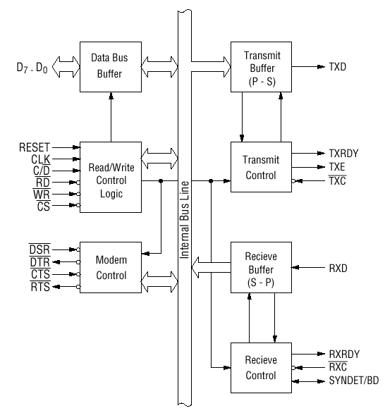
Block diagram of the 8251 USART (Universal Synchronous Asynchronous Receiver Transmitter)
……………………………………………………………………………………………..

Lecture # 4

Synopsis

8251A components and working

Interfacing of 8251A
- Target
By this lecture you should be able to answer the following questions
  - How the data is converted during transmission?
  - How the functions are defined to control the operation of USART?

3. Introduction
8251A is a programmable peripheral designed for synchronous /asynchronous serial data communication, packaged in a 28-pin DIP. It includes five sections:
      - Read/Write Control Logic
      - Modem Control
      - Data Bus buffer
      - Transmitter
5) Receiver
4. Concepts
Read/Write Control logic
This section includes a control logic, six input signals, and three buffer registers: Data register, control register and status register. The control logic interfaces the chip with MPU, determines the functions of the chip according to the control word in the control register and monitors the data flow.
Input signals
- CS – Chip Select: When this signal goes low, the 8251A is selected by the MPU for communication.
- C/D – Control/Data: When this signal is high, the control or status register is addressed; when it is low, data buffer is addressed. The control register and status register are differentiated by WR and RD signals.
- WR: When this signal is low, the MPU either writes in the control register or sends output to the data buffer
- RD: When this signal goes low, the MPU either reads a status from the status register or accepts data from data buffer.
- RESET: A high on this signal reset 8252A and forces it into the idle mode.
- CLK: This is the clock input, usually connected to the system clock for communication with the microprocessor.
Control Register
The 16-bit register for a control word consist of two independent bytes. : the first byte is called mode word and the second byte is called the command word. The mode word specifies the general characteristics of operation such as baud, parity, number of bits etc. But the command word enables the data transmission and reception. The register can be accessed as an output port when the Control/Data pin is high.
Status register
This input register checks the ready status of the peripheral. The status word in the status register provides the information concerning register status and transmission errors.
Data buffer
This bidirectional register can be used as an input and output port when the C/D is low.
CS | C/D | WR | RD | Operation
0  0  0  0  1 | 0  0  1  1  × | 1  0  0  1  × | 0  1  1  0  × | MPU reads data from data buffer  MPU writes data from data buffer  MPU writes a word to control register  MPU reads a word from status register  Chip is not selected for any operation
Transmitter section
The transmitter accepts parallel data from MPU and converts them into serial data. It has two registers:
- buffer register to hold eight bits
- output register to convert eight bits into a stream of serial bits.
Transmit control
Output Register
Transmitter Buffer

Transmitter Buffer

The MPU writes a byte in the buffer register, whenever the output register is empty; the contents of buffer register are transferred to output register. And transmit the data on the TxD pin with appropriate framing bits. Three output and one input signals are associated with this transmitter section.
TxD: This is an output signal to transmit the data to peripherals
TxC: An in put signal controls the rate of transmission.
TxRDY: An output signal, indicate the buffer register is empty and the USART is ready to accept the next data byte.
TxE: An output signal to indicate the output register is empty and the USART is ready to accept the next data byte.
Receiver Section
Receiver section accepts serial data on the RxD pin and converts them to parallel data. This section has two registers:
- the receiver input register
- The buffer register.
RxD
Receive Buffer
Receive control
Input Register

RxRDY
RxC
When the RxD goes low, the control logic assumes it is a start bit, waits for half bit time, and samples the line again. If the line is still low, the input register accepts the following data, and loads it into buffer register at the rate determined by the receiver clock.
RxRDY- receiver Ready: This is an output signal. It goes high when the USART has a character in the buffer register and is ready to transfer it to the MPU.
RxD- Receive data: Bits are received serially on this line and converted into a parallel byte in the receiver input register.
RxC- Receiver clock: This is clock signal that controls the rate at which bits are received by the USART.
…………………………………………………………………………………………

